Stay out/ lock out/ let in/ log out/ fill in/ hand in/ pull out/ put out/ take out /

Ask in/ pass out.

To stay out = not to return home أن تسهر خارج البيت
The children mustn't stay out after 9 p.m
To Lock out = to leave somebody out of a building
تغلق الأبواب لتمنع من الدخول
Sara was so angry at her brother that she locked him out of the house
To Let in = to allow somebody access to a building
أن يسمح بالدخول
Visitors with an ID card were let in
Log out = exit a computer
أن تترك تصفح الإنترنيت
You should log out after you read your e-mails
Fill in = to write down
يملأ استمارة
All visa applicants must fill in a form
Hand in = to submit a paper, a document يسلم
The students hand in their exams to the teacher
Pull out = to leave يترك/يغادر
The ship pulled out of the harbour
Put out = extinguish أطفئ
The firemenan put out the fire
Take out = to take out for a walk يأخذ للتنزه
He takes my little sister out now and then
Ask in = ask to enter أن تعزم – أحد على شاي مثلا -
We asked the neighbors in for a cup of coffee
Pass out = to lose consciousness
When she heard about the death of her husband, she passed out
أغمى عليها عندما سمعت خبر وفاة زوجها
Start out تبدأ رحلة
To begin a journey; to start off
We shall have to start out at dawn
Let out أن تطلق صوتا
To express audibly
She let out a cry when she saw a snake
Watch out أن تحذر
To be on one's guard; be cautious
Watch out for cars when you cross the road
Find out تكتشف
To discover or confirm the truth of
The police found out the killer
Sneak out of أن تتسلل
To go in a stealthy or furtive manner
The kids sneaked out of the house when the mother refused to let them out
Check in تتسجل في فندق
To register, as at a hotel
They checked in before going to their hotel room
To knock out أن تطرح أرضا فاقدا الوعي
To render unconscious
The boxer knocked out his opponenent
Come out أزال
To be removed
This dirty mark won't come out

Put: Take out/ Fill in/ Pull out/ stay out/ pass out/ log out
in the following sentences

The rescue services are still trying to ........... ....... the fires
He started ......... ............ late , drinking when his family was away
I nearly .......... ............ when I saw all the blood
Don't forget to ...... ........ your boarding cards
To ...... ...... is stop using a computer system by giving it particular instructions
If a train , it leaves a station
......Don't leave them standing on the doorstep - ......... them
I am ........ my friend Jane ..... for a dinner next week

Exercise : A- Add the right preffix or suffix
In their investigation for sound evidence, the police .......played the cassette many times
Officials know that such policy has predict ........ consequences
The fans of the visitor team ..............number the fans of our team
The situation is suit ............... to ask for an increase in your salary
Some officials ............use their powers
If you don’t .............operate and join our efforts, we won’t succeed in human development
Barbara came to the party with a lovely fashion ........... dress
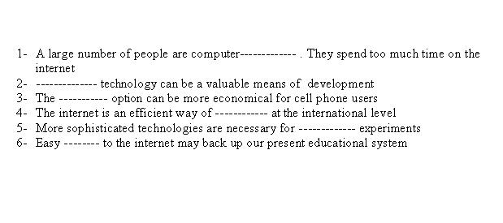
We went to the cinema yesterday, but the film was horr i............ We didn’t like it

